**Q1: How to read multiple Objects from a file using loop? (Loop till null wont work)**

**A1:** If you're storing multiple objects in a file and want to read them without knowing the exact count beforehand, one common approach is to use a try-catch block to handle the end of the file. In Java, when you attempt to read an object from a file using ObjectInputStream, it will throw an **EOFException** when it reaches the end of the file. You can use this exception to exit the loop. Here's an example:

**import java.io.*;**

**public class ReadEx {**

**public static void main(String args[]) {**

**try (ObjectInputStream ois = new ObjectInputStream(new FileInputStream("persons.txt"))) {**

**// Use a try-catch block to handle the end of the file**

**try {**

**while (true) {**

**PersonInfo p = (PersonInfo) ois.readObject();**

**p.printPersonInfo();**

**}**

**} catch (EOFException e) {**

**// End of file reached, do nothing**

**}**

**} catch (Exception e) {**

**System.out.println(e);**

**}**

**}**

**}**

import java.io.*;

public class ReadEx {

public static void main(String args[]) {

try {

ObjectInputStream ois = new ObjectInputStream(new FileInputStream("persons.txt"));

// Use a try-catch block to handle the end of the file

try {

while (true) {

PersonInfo p = (PersonInfo) ois.readObject();

p.printPersonInfo();

}

} catch (EOFException eofException) {

// End of file reached, do nothing

}

ois.close();

} catch (Exception e) {

System.out.println(e);

}

}

}

**Q2: Check if following functionality will also be serialized?**

**A2:**

**(i)Private Data Members:**

Yes, private data members can be serialized as long as the class implements the Serializable interface. The access modifiers (private, public, etc.) do not affect the serialization process; it depends on whether the class itself is serializable.

**(ii)Static Data Members:**

No, static data members are not serialized. Serialization is concerned with the state of an object, and static members belong to the class, not to an instance of the class. When an object is serialized, only the instance variables are serialized, and static variables are shared among all instances of the class, so they are not included in the serialization process.

**(iii) Final Data Members:**

Yes, final data members can be serialized. The final keyword only ensures that the variable is assigned a value only once, but it does not affect serialization. Final fields will be included in the serialization process if the class implements the Serializable interface.

**Q3: How to use externalizable interface for reading and writing objects?**

**A3: Interface Externalizable**

The **writeExternal and readExternal** methods of the Externalizable interface are implemented by a class to give the class complete control over the format and contents of the stream for an object and its supertypes. These methods must explicitly coordinate with the supertype to save its state. These methods supersede customized implementations of writeObject and readObject methods.

* The Externalizable interface in Java provides a way to customize the serialization and deserialization process for objects. Unlike the Serializable interface, which performs serialization automatically, the Externalizable interface requires you to implement two methods: writeExternal for serialization and readExternal for deserialization. This allows you to have more control over how the object is written to and read from a stream.

Here's an example demonstrating the use of the Externalizable interface:

**import java.io.*;**

**class CustomObject implements Externalizable {**

**private int intValue;**

**private String stringValue;**

**// Default constructor (required for Externalizable)**

**public CustomObject() {**

**}**

**public CustomObject(int intValue, String stringValue) {**

**this.intValue = intValue;**

**this.stringValue = stringValue;**

**}**

**@Override**

**public void writeExternal(ObjectOutput out) throws IOException {**

**// Implement custom serialization**

**out.writeInt(intValue);**

**out.writeUTF(stringValue);**

**}**

**@Override**

**public void readExternal(ObjectInput in) throws IOException, ClassNotFoundException {**

**// Implement custom deserialization**

**intValue = in.readInt();**

**stringValue = in.readUTF();**

**}**

**public void printValues() {**

**System.out.println("Int Value: " + intValue);**

**System.out.println("String Value: " + stringValue);**

**}**

**}**

**public class ExternalizableExample {**

**public static void main(String[] args) {**

**try (ObjectOutputStream oos = new ObjectOutputStream(new FileOutputStream("externalizable.ser"));**

**ObjectInputStream ois = new ObjectInputStream(new FileInputStream("externalizable.ser"))) {**

**CustomObject obj1 = new CustomObject(42, "Hello");**

**// Serialize the object**

**oos.writeObject(obj1);**

**// Deserialize the object**

**CustomObject obj2 = (CustomObject) ois.readObject();**

**// Print values after deserialization**

**obj2.printValues();**

**} catch (IOException | ClassNotFoundException e) {**

**e.printStackTrace();**

**}**

**}**

**}**

**OR**

**import java.io.Externalizable;**

**import java.io.IOException;**

**import java.io.ObjectInput;**

**import java.io.ObjectOutput;**

**// A simple class representing a person**

**class Person implements Externalizable {**

**private String name;**

**private int age;**

**// No-argument constructor (required for Externalizable)**

**public Person() {}**

**// Parameterized constructor**

**public Person(String name, int age) {**

**this.name = name;**

**this.age = age;**

**}**

**// Getters and setters (optional)**

**@Override**

**public void writeExternal(ObjectOutput out) throws IOException {**

**// Implement serialization manually**

**out.writeObject(name);**

**out.writeInt(age);**

**}**

**@Override**

**public void readExternal(ObjectInput in) throws IOException, ClassNotFoundException {**

**// Implement deserialization manually**

**name = (String) in.readObject();**

**age = in.readInt();**

**}**

**@Override**

**public String toString() {**

**return "Person{" +**

**"name='" + name + '\'' +**

**", age=" + age +**

**'}';**

**}**

**}**

**public class ExternalizableExample {**

**public static void main(String[] args) {**

**// Serialization**

**try {**

**Person person = new Person("Alice", 30);**

**// Writing object to file**

**java.io.FileOutputStream fileOut = new java.io.FileOutputStream("person.ser");**

**java.io.ObjectOutputStream out = new java.io.ObjectOutputStream(fileOut);**

**out.writeObject(person);**

**out.close();**

**fileOut.close();**

**System.out.println("Person object serialized successfully.");**

**} catch (IOException e) {**

**e.printStackTrace();**

**}**

**// Deserialization**

**try {**

**// Reading object from file**

**java.io.FileInputStream fileIn = new java.io.FileInputStream("person.ser");**

**java.io.ObjectInputStream in = new java.io.ObjectInputStream(fileIn);**

**Person person = (Person) in.readObject();**

**in.close();**

**fileIn.close();**

**System.out.println("Person object deserialized successfully.");**

**System.out.println("Deserialized Person: " + person);**

**} catch (IOException | ClassNotFoundException e) {**

**e.printStackTrace();**

**}**

**}**

**}**

In this example:

* The CustomObject class implements the Externalizable interface.
* The writeExternal method is called during serialization and is responsible for writing the object's state to the ObjectOutput stream.
* The readExternal method is called during deserialization and is responsible for reading the object's state from the ObjectInput stream.
* The printValues method is just a utility method to print the values of the object after deserialization.

When you run this example, you'll see that the CustomObject class controls how its data is written and read during the serialization and deserialization processes.

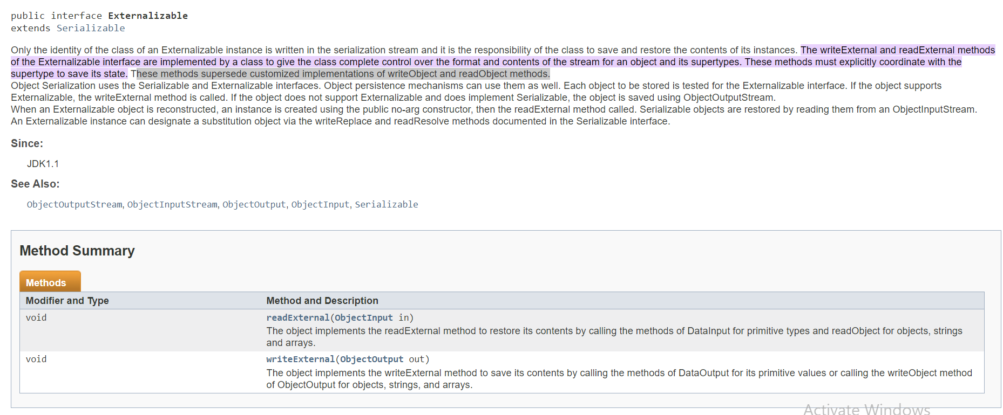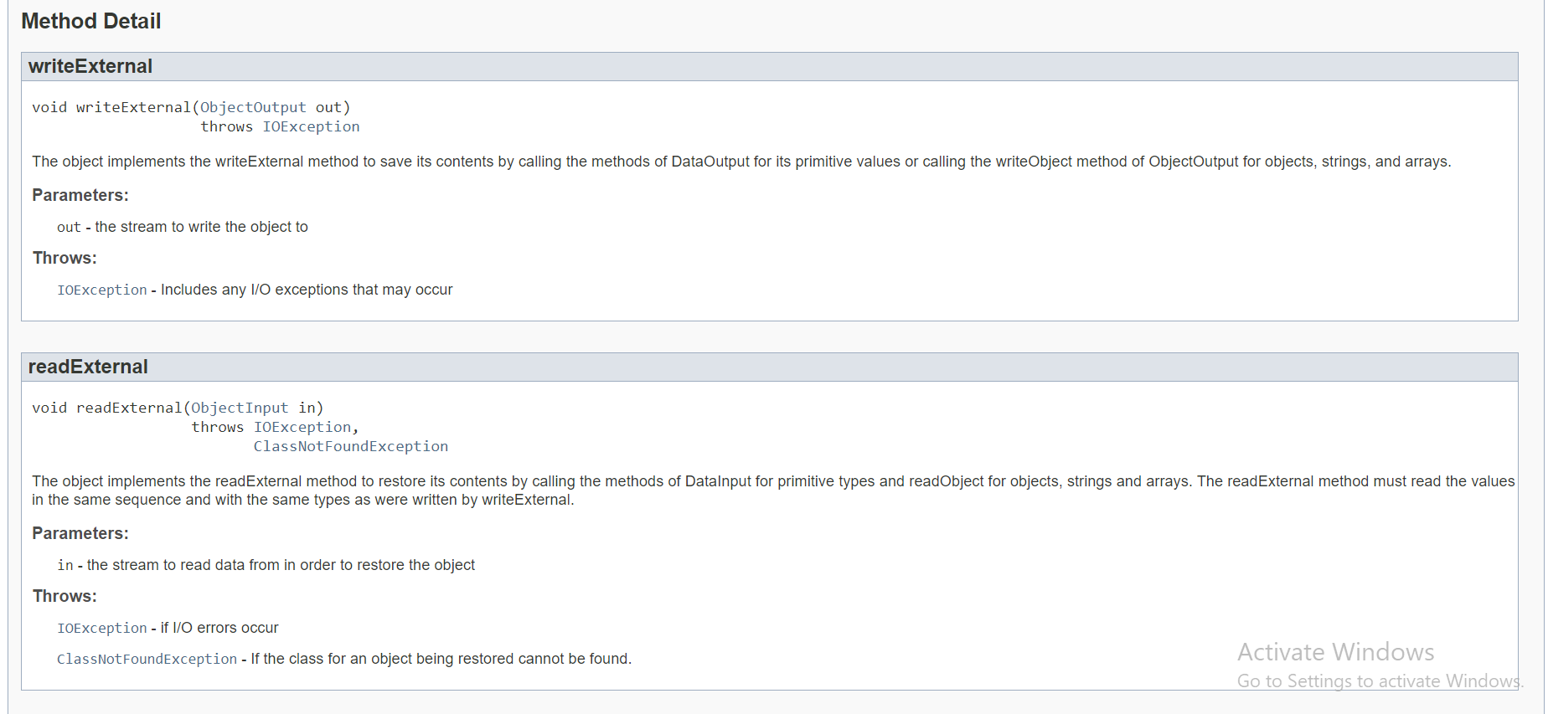

**Q4: What is the purpose of InputStreamReader (name of class)?**

**A4:**

public class **InputStreamReader**

extends [Reader](https://docs.oracle.com/javase/8/docs/api/java/io/Reader.html)

An **InputStreamReader is a bridge from byte streams to character streams:** It reads bytes and decodes them into characters using a specified [charset](https://docs.oracle.com/javase/8/docs/api/java/nio/charset/Charset.html). The charset that it uses may be specified by name or may be given explicitly, or the platform's default charset may be accepted.

Each invocation of one of an InputStreamReader's read() methods may cause one or more bytes to be read from the underlying byte-input stream. To enable the efficient conversion of bytes to characters, more bytes may be read ahead from the underlying stream than are necessary to satisfy the current read operation.

For top efficiency, consider wrapping an InputStreamReader within a BufferedReader. For example:

**BufferedReader in = new BufferedReader(new InputStreamReader(System.in));**

=>

he **InputStreamReader** class in Java is a bridge between byte streams and character streams. It is part of the **java.io** package and extends the **Reader** class. The purpose of **InputStreamReader** is to convert bytes from an **InputStream** into characters, using a specified character encoding.

Here's a brief explanation of its purpose:

1. **Bridge Between Byte Streams and Character Streams:**
   * **InputStreamReader** acts as a bridge between byte-oriented streams (like **FileInputStream**, **ByteArrayInputStream**, etc.) and character-oriented streams (like **FileReader**, **StringReader**, etc.).
2. **Character Encoding:**
   * One of the key features of **InputStreamReader** is that it allows you to specify a character encoding. When you read bytes from an input stream, they need to be interpreted and converted into characters. The character encoding specifies the mapping between the byte values and the corresponding characters.
3. **Default Encoding:**
   * If you don't explicitly specify a character encoding, the platform's default character encoding is used. However, it's generally a good practice to explicitly define the encoding to avoid potential issues related to platform differences.
4. **Use in Reading Text Data:**
   * **InputStreamReader** is often used when reading text data from an input stream. For example, when reading from a file, you can use **FileInputStream** in combination with **InputStreamReader** to read the file's contents as characters.

**Q5: What is the optimal size of buffer in BufferInputStream?**

**A5:**

The optimal size of the buffer in **BufferedInputStream** depends on various factors such as the nature of your application, the type of data being read, and the underlying I/O operations. However, there are some general guidelines you can consider:

1. **Multiple of 2:**
   * Buffer sizes that are powers of 2 (e.g., 1024, 2048) are often recommended. This is because many underlying systems and file systems work well with data in powers of 2.
2. **Experimentation:**
   * It's often a good idea to experiment with different buffer sizes to find the optimal one for your specific use case. The performance may vary based on factors like the size of the data being read, the type of storage medium (e.g., HDD vs. SSD), and the specific I/O patterns of your application.
3. **Consider System Defaults:**
   * In many cases, using the default buffer size provided by the constructor (**BufferedInputStream(InputStream in)**) is sufficient. The default size is often designed to work well in a variety of scenarios.
4. **Memory Constraints:**
   * Consider the memory constraints of your application. Larger buffer sizes can improve performance, but they may also increase memory usage. If memory is a critical resource, you might want to choose a more moderate buffer size.
5. **I/O Performance:**
   * In some situations, the performance may be influenced by factors such as disk access patterns or network latency. Adjust the buffer size based on the characteristics of the I/O operations in your specific scenario.

**Q6: What is the use of flush function in Stream classes?**

**A6:**

The **flush()** method is used to clear the output buffers of a stream. It ensures that any buffered data is written to the underlying data sink (such as a file, network socket, or other output destination) immediately, without waiting for the buffer to be filled completely.

In Java, the **flush()** method is commonly associated with output stream classes, especially those that involve writing data to external destinations. Here are a few key points about the **flush()** method:

1. **Buffered Output:**
   * Many stream classes use buffering to improve performance. When you write data to an output stream, it may not be immediately sent to the destination. Instead, it is first stored in an internal buffer. The **flush()** method ensures that any buffered data is promptly sent to the destination.
2. **Preventing Data Loss:**
   * In scenarios where data integrity is crucial, calling **flush()** can be important. If you have written data to a stream but have not yet closed it, there's a risk that the data might not be completely written if the program terminates unexpectedly. Flushing the stream ensures that data is persisted before any potential program termination or closure.
3. **Network Communication:**
   * For output streams involved in network communication (e.g., **OutputStream** connected to a socket), calling **flush()** can be necessary to ensure that data is sent immediately over the network rather than waiting for the buffer to fill.

**Q7: How can we redirect std OutputStream to a file rather than console? (Hint: Set out function in system class.)**

**A7:**

To redirect the standard output (**System.out**) to a file in Java, you can use the **System.setOut()** method. This method allows you to change the output stream to a different **PrintStream**, which can be associated with a file. Here's an example:

**import java.io.*;**

**public class RedirectSystemOut {**

**public static void main(String[] args) {**

**// Save the current System.out to restore it later if needed**

**PrintStream originalOut = System.out;**

**try {**

**// Create a new FileOutputStream to a file (e.g., output.txt)**

**FileOutputStream fileOutputStream = new FileOutputStream("output.txt");**

**// Create a new PrintStream using the FileOutputStream**

**PrintStream filePrintStream = new PrintStream(fileOutputStream);**

**// Redirect System.out to the new PrintStream**

**System.setOut(filePrintStream);**

**// Now, anything printed to System.out will be written to the file**

**// Example: Printing to System.out**

**System.out.println("Hello, this will be written to the file.");**

**} catch (FileNotFoundException e) {**

**e.printStackTrace();**

**} finally {**

**// Restore the original System.out to avoid unexpected behavior**

**System.setOut(originalOut);**

**}**

**// After this point, System.out is back to its original state**

**System.out.println("This will be printed to the console, not the file.");**

**}**

**}**

In this example:

1. The original **System.out** is saved in the **originalOut** variable.
2. A new **FileOutputStream** is created, associated with a file (e.g., "output.txt").
3. A new **PrintStream** is created using the **FileOutputStream**.
4. **System.setOut()** is called to redirect **System.out** to the new **PrintStream**.
5. Any subsequent output to **System.out** will be written to the file.

Remember to restore the original **System.out** at the end of the program or when you no longer need redirection to avoid unexpected behavior in other parts of your application.

**Q8: Similar to ArrayList, how we can use hashmap?**

**A8:**   
In Java, **HashMap** is a collection class that implements the **Map** interface. It stores key-value pairs and allows you to associate a value with a unique key. Here's a basic example of how to use **HashMap**:

**import java.util.HashMap;**

**import java.util.Map;**

**public class HashMapExample {**

**public static void main(String[] args) {**

**// Creating a HashMap**

**Map<String, Integer> hashMap = new HashMap<>();**

**// Adding key-value pairs**

**hashMap.put("Alice", 25);**

**hashMap.put("Bob", 30);**

**hashMap.put("Charlie", 28);**

**// Accessing values by key**

**System.out.println("Bob's age: " + hashMap.get("Bob"));**

**// Checking if a key exists**

**if (hashMap.containsKey("Alice")) {**

**System.out.println("Alice is in the HashMap.");**

**}**

**// Iterating over key-value pairs**

**System.out.println("HashMap contents:");**

**for (Map.Entry<String, Integer> entry : hashMap.entrySet()) {**

**System.out.println(entry.getKey() + ": " + entry.getValue());**

**}**

**// Removing a key-value pair**

**hashMap.remove("Charlie");**

**// Size of the HashMap**

**System.out.println("Size of the HashMap: " + hashMap.size());**

**}**

**}**

In this example:

* A **HashMap** is created with keys of type **String** and values of type **Integer**.
* Key-value pairs are added using the **put** method.
* Values are accessed by key using the **get** method.
* The **containsKey** method is used to check if a key exists in the **HashMap**.
* The **entrySet** method is used for iterating over key-value pairs.
* The **remove** method is used to remove a key-value pair.
* The **size** method returns the number of key-value pairs in the **HashMap**.

Remember that keys in a **HashMap** must be unique. If you try to add a key-value pair with an existing key, the new value will overwrite the existing value associated with that key.

Additionally, it's worth noting that **HashMap** allows **null** as a key and as a value. If you need a map with ordering based on the order of insertion, you might consider using **LinkedHashMap**. If you need a thread-safe map, you can use **Hashtable** or **ConcurrentHashMap**.

**Q9: In an ArrayList, how we can insert an item to desired index rather than at end?**

**A9:**

In Java's **ArrayList**, you can insert an element at a specific index using the **add(int index, E element)** method, where **index** is the index at which you want to insert the element, and **element** is the element you want to insert. Here's an example:

**import java.util.ArrayList;**

**public class ArrayListInsertExample {**

**public static void main(String[] args) {**

**// Creating an ArrayList of Strings**

**ArrayList<String> arrayList = new ArrayList<>();**

**// Adding elements to the ArrayList**

**arrayList.add("Apple");**

**arrayList.add("Banana");**

**arrayList.add("Orange");**

**// Displaying the ArrayList before insertion**

**System.out.println("ArrayList before insertion: " + arrayList);**

**// Inserting a new element at index 1**

**arrayList.add(1, "Grapes");**

**// Displaying the ArrayList after insertion**

**System.out.println("ArrayList after insertion: " + arrayList);**

**}**

**}**

In this example:

* The **add** method is used to add three elements ("Apple", "Banana", "Orange") to the **ArrayList**.
* Before insertion, the contents of the **ArrayList** are displayed.
* The **add(1, "Grapes")** method is used to insert the element "Grapes" at index 1.
* After insertion, the updated contents of the **ArrayList** are displayed.

The output of the program will be:

**ArrayList before insertion: [Apple, Banana, Orange]**

**ArrayList after insertion: [Apple, Grapes, Banana, Orange]**

As you can see, "Grapes" is inserted at index 1, shifting the elements after that index to the right. The index is zero-based, so **add(1, "Grapes")** inserts "Grapes" at the second position in the ArrayList.